One of the coldest places in the country - Peter Sinks yet again sets this year’s coldest temperature record for the contiguous United States.
In the early morning of February 22, 2010 the temperature at Peter Sinks in the Wasatch Cache National Forest in eastern Cache County, Utah reached a bone chilling -46º F – the coldest recorded temperature in the contiguous United States this year! That day, no other station in the country—including Alaska—was within 21 degrees of Peter Sinks (-25 record at Shirley Basin, Wyoming). Logan’s low temperature for the day was 3.2 º F.
From October to March 17, Peter Sinks has had the lowest temperature in the lower 48 states on 50 different days according to Trent McCotter, a University of North Carolina Law School student and extreme weather guru. On 13 of these 50 days, Peter Sinks was colder than the coldest spot in Alaska. The next record holder, West Yellowstone, MT falls far behind with 11 lowest temperature days (10/25 thru 3/17, Alaska excluded).

The extreme cold temperatures at Peter Sinks are not unique to this year. On Feb. 1, 1985, the temperature at this location plummeted to -69.3º F, the second coldest ever recorded in the lower 48 states. The lowest was -69.7º F at Roger's Pass, Montana in January 1954. Moreover, Peter Sinks and nearby Middle Sink have the distinction of having all but one of the monthly low temperature records for Utah (table 1).
Table1. Monthly lowest temperature records
month | temperature (F) | year | location | observer
January | -66 | 1985 | Peter Sinks | Zane Stephens
February | -69.3 | 1985 | Peter Sinks | Zane Stephens
March | -52 | 2002 | Middle Sink | Zane Stephens & Tim Wright
April | -41 | 2008 | Middle Sink | Tim Wright
May | -19 | 1983 | Peter Sinks | Zane Stephens
June | 3 | 2001 | Peter Sinks | Zane Stephens & Tim Wright
August | 7 | 2005 | Peter Sinks | Zane Stephens & Tim Wright
September | -10 | 2000 | Peter Sinks | Zane Stephens & Tim Wright
October | -35 | 2002 | Peter Sinks | Zane Stephens & Tim Wright
November | -47 | 2003 | Middle Sink | Campbell Scientific station
December | -54 | 1990 | Middle Sink | Zane Stephens

So why is this montane site, located 20 miles northeast of Logan, so cold? The low temperatures are due to a combination of the area’s unique basin topography, high elevation and dry climate. Peter Sinks, at an elevation of 8,164 feet, is a natural limestone sinkhole approximately one-half mile in diameter; one can liken it to a large bowl, which has no valley outlet to drain water or air. On calm cloudless nights this high basin looses accumulated daytime heat to the atmosphere. In addition, cool dense air slides down-slope into the basin floor in a process known as cold air pooling. Extremely low temperatures can occur, especially in the wake of the passage of wintertime arctic fronts.
Temperatures in the Peter Sinks area have been monitored sporadically since the early 1980s. During the winters of 1983 and 1984, Utah State University students Zane Stephens and Mike Bowman routinely trekked to the adjacent Middle Sinks and measured temperatures using alcohol thermometers (alcohol is used in liquid thermometers when low temperatures are expected as mercury freezes at -40 º F). The data they collected was reported to Weatherbank, Inc. a weather products and services company headquartered in Salt Lake City. Then in 1984, with cooperation from the Utah Climate Center, they installed a National Weather Service Cooperative Observer Program (COOP) instrument shelter containing a minimum recording thermometer on the southwest side of Peter Sinks northern lobe. Concurrently Weatherbank, concerned about the difficulty of accessing this new site to retrieve data, contacted Campbell Scientific of Logan, Utah, an internationally recognized manufacturer of measurement technology, to explore the possibility of installing an automated weather station with radio telemetry for remote data collection. They chose to erect their instrument tower approximately 300 yards to the northeast of the site Stevens and Bowman were using, and installed radio repeaters at the rim to the south and Logan Peak, 18 miles to the east. The final telemetry leg was to a base station radio at Campbell Scientific’s corporate headquarters in Logan.
On February 1, 1985 the Campbell Scientific station digitally recorded a temperature of -70.5 º F from a thermocouple sensor at 20 inches above the snow surface. A few days later, Zane retrieved his alcohol thermometer, which recorded a minimum temperature of -68.3 º F. The National Bureau of Standards calibrated the thermometer and after adjustment officially established the low at -69.3 º F; this temperature became the ‘official’ temperature minimum since at that time the National Weather Service only recognized COOP type stations. The stations were decommissioned after the winter of 1985.
Next in the sequence of events was in October of 2003, when Utah State University students Tim Wright and Joshua Campbell installed a portable automated metrological station at the site of the 1984 Campbell Scientific station. Shortly after monitoring began, the temperature sank to a November monthly record of -46 º F. The station on loan from Campbell Scientific was taken down the following spring.
This past year, the Utah State Climate Center obtained a seasonal permit from the US Forest Service to set up a temperature monitoring station in the same location as the previous two Campbell Scientific station deployments. The project has support from Campbell Scientific. The automated station logs temperature at 3 elevations (1, 2.75, & 3.5m) along with wind speed and direction. Data is transmitted to the Utah Climate Center in Logan through a repeater station on the north rim of the sinks, 270 feet higher than the instruments at the bottom of the basin. Wind speed, relative humidity and temperature are also recorded at the rim to quantify the gradient between the 2 stations.

Figure 1. Air temperature and wind speed at Peter Sinks basin (blue & gray lines) and Peter Sinks rim (red & dashed black lines) during record low temperature period in February of 2010. Note that 1.) temperature lows occur around dawn and 2.) the relationship between calm wind conditions and lower temperatures. Also note the rate of temperature change (for example on February 22, the temperature increased 79º F in just 4.5 hours!). In the early morning of February 22, the temperature difference between the rim and basin floor reached 48º F. On the following morning when winds increased, the temperature difference averaged 1º F.
← Record low

Table 2. Extreme temperature changes at Peter Sinks compiled by Trent McCotter - 10/01/09 through 2/13/2010.
interval | temperature change | Date | initial temperature & time | final temperature & time | comment
15 minutes | +32.2 | 1/9/2010 | -7.1 F at 1:15am | 25.1 F at 1:29am
 | +28.3 | 2/13/2010 | -10.7 F at 9:45pm | 17.6 F at 9:54pm | nine minutes!
 | -13.3 | 3/15/2010 | 42.9 F at 5:33pm | 29.3 F at 5:45pm
30 minutes | +42.4 | 1/12/2010 | -7.8 F at 8:45am | 34.6 F at 9:14am
 | -19.0 | 11/26-27/2009 | 32.8 F at 11:47pm | 13.8 F at 12:14am
60 minutes | +48.1 | 1/12/2010 | -13.6 F at 8:15am | 34.6 F at 9:14am
 | -25.6 | 1/24/2010 | 9.9 F at 9:02pm | -15.7 F at 9:57pm

Figure 2. Peter Sinks basin station – Fall 2009
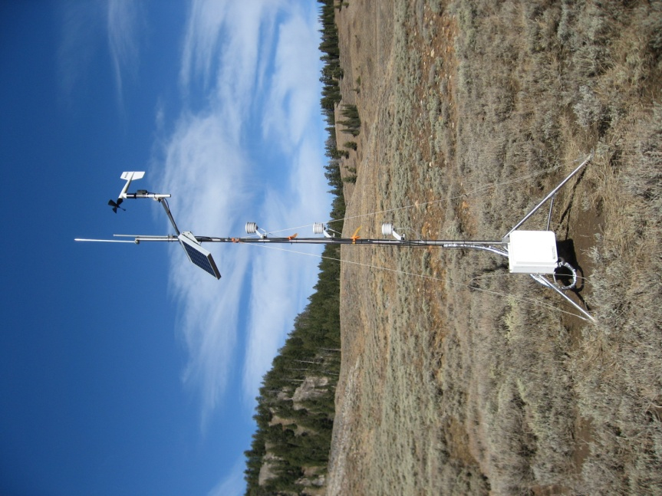

Figure 3. Peter Sinks rim station – late Fall 2009
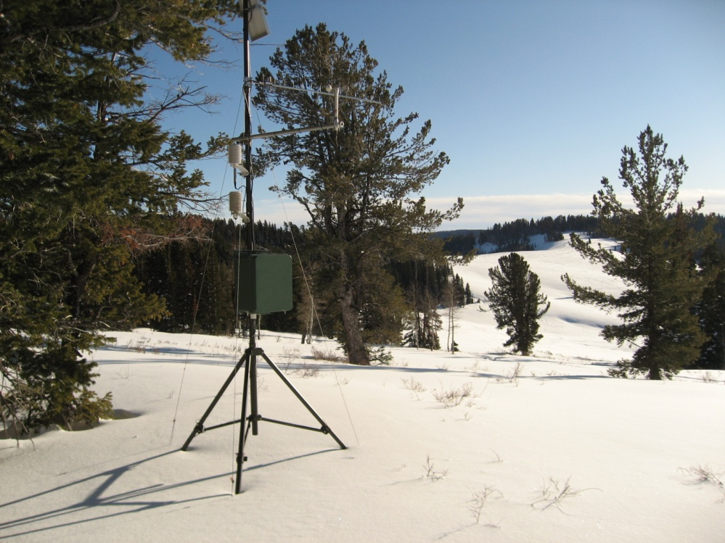

References:
Campbell, Eric, and B. Tanner, 1987: High Mountain Valley Inversions: Measurement of Extreme Low Temperatures. Sixth Symposium on Meteorological Observations and Instrumentation – American Meteorological Society, New Orleans, Louisiana January 12-16, 1987.
Clements, C. B., C. D. Whiteman, J. D. Horel, 2003: Cold-air-pool structure and evolution in a mountain basin: Peter Sinks, Utah. J. Appl. Meteor., 42 (6), 752-768.
Arave, Lynn, 1990: Peter Sinks: Utah’s Coldest Spot. Article published in Deseret News August 8, 1990.
Bauman, Joe, 2006: Think it’s cold here? Check out Sinks area. Article published in Deseret News February 17, 2006.

